Date: 21.05.2021
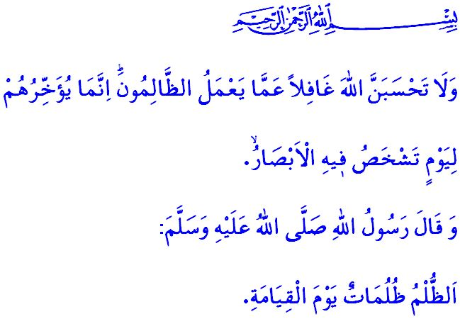
OPPRESSION AND WRONGDOING CANNOT GO UNPUNISHED
Honorable Muslims!
In the verse I have recited, our Lord Almighty (swt) states as follows, “And never think that Allah is unaware of what the wrongdoers do. He only delays them [i.e., their account] for a Day when eyes will stare [in horror].”
This verse is a hope and consolation for the oppressed, and a warning and threat for the oppressors. The oppressors who ignore this threat will find no peace either in this world or in the Hereafter. They will taste disgrace in worldly life, and a greater punishment in the Hereafter. As in the words of the Prophet Muhammad (saw), “Oppression will be a darkness for oppressors on the Day of Resurrection.”
Dear Believers!
We are living at a time when feelings of mercy, conscience, and compassion are missing, oppression is second nature, and oppressors have all the support. The persecutors who recognize no rights or laws are raining bombs on the oppressed people of Palestine, without any distinction as to the children, the elderly, and the women. The raving murderers are massacring our innocent Palestinian brothers and sisters before the eyes of the international community. Those who feed on blood and tear are forcing, with pressure and violence, the Muslims living in and about al-Quds out of their homes and homelands, and usurping their right to life. They tread upon the divinity of the Masjid al-Aqsa by not recognizing the inviolability of sanctuaries. But we believe that there is no barrier between the oppressed and Allah (swt). Our Lord, al-Qahhar, will vanquish the oppressors, leaving them miserable.
Dear Muslims!
Believers do not take side with or laud oppression. They do not remain silent in the face of oppression or be the voice of oppressors. A believer’s heart is never content with oppression. A believer stands by the truth and justice, always firmly against oppression. A believer is the enemy of oppressors and the hope of the oppressed. No matter where on the face of the earth, a believer’s heart aches in the face of a bleeding wound. For a believer is submitted to Allah (swt) and a walker of the path to Him (swt). A believer knows that the grace and help of Allah (swt) will be with them as long as they are in the service of the truth and justice. As long as they uphold the truth, oppressors will never be able to inflict any harm on the oppressed and the victimized.
Dear Believers!
The Prophet Muhammad (saw) states in a hadith as follows, “Whosoever of you sees an evil, let him change it with his hand; and if he is not able to do so, then [let him change it] with his tongue; and if he is not able to do so, then with his heart — and that is the weakest of faith.”
As the cry-outs of the oppressed people reach the clouds, we as the Prophet Muhammad’s ummah should come together and stand against the oppression and occupation. We should help our oppressed brothers and sisters as much as we can. We should know that the oppressors are going to have a very bitter end with the help of our Lord (swt) and the unity, discernment, courage and honorable stance of believers; and those who target peace and order are going to have their punishment sooner or later.
Dear Muslims!
What is happening in Palestine today loads important responsibilities on us. Today is the day for us to hit the road with such discernment as would fit a Muslim and submit our sincerity to our Lord (swt). Today is the day for us to embrace the Prophet Muhammad’s (saw) ideal of ummah. Today is the day for us to be one with our brothers and sisters. After the Friday prayer, I will kindly invite you to extend a helping hand to our Palestinian brothers and sisters to dress their wounds. May Allah the Almighty (swt) accept our good deeds.

Ibrahim, 14/42.
Bukhari, Mazalim, 10.
Bukhari, Zakat, 63.
Muslim, Iman, 78. General Directorate of Religious Services

